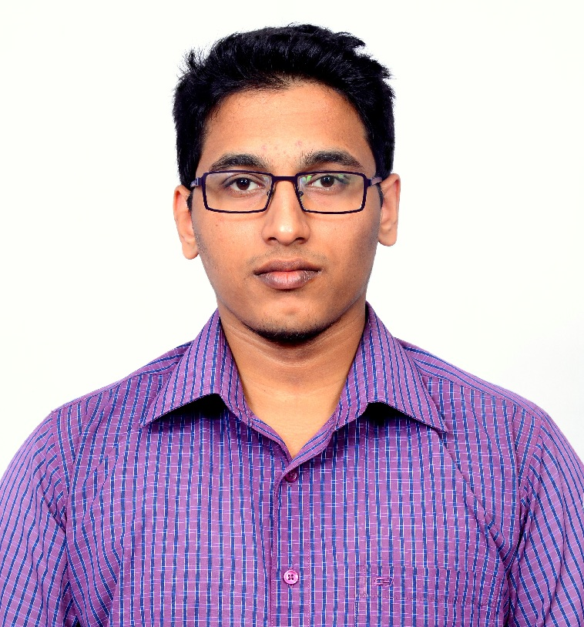
RISHABH RAJIV MANERKAR
House No.: 223/B, Near P.W.D Qtrs,
Katem Baina, Vasco Da Gama. GOA – 403802 (INDIA).
Mobile: (+91) 9762416825/ 7507959540
Email: rishabhmanerkar@gmail.com

PROFILE SUMMARY:
- Offering under 1 year of experience as Electronic Engineer in Instrumentation field.
- Possess extensive knowledge in PLC programming and Industrial Automation.
- Experience in handling complete electrical progress work inspections on continuous basis along with complete end electrical installations checkout

CAREER OBJECTIVE:

I am looking ahead to work in a professional, growth oriented organization, where in one can make significant contribution to the success of the organization. Seeking a position that involves creativity, challenges and that provides me, an opportunity to constantly strive to explore, innovate & excel in attaining organizational and my individual goals. A consistently dependable team player, I can thrive in a high-pressure environment, enjoy the challenges of meeting deadlines and working in a team.

EDUCATION BACKGROUND:
QUALIFICATION | BOARD / UNIVERSITY | YEAR OF PASSING | GRADE / MARKS
B.E Electronics and Telecommunication | Goa College Of Engineering, Goa | 2015 | 75.9%
HSSCE | MES Higher Secondary School, Goa | 2011 | 67.17%
SSC | Mata Secondary School, Goa | 2009 | 83.67%

EXPERIENCE:

- Working as “Senior Engineer” with Adage Automation Pvt Ltd. Goa. From March 2016 to till date.

Key Responsibilities:
- Installation, Testing and commissioning of Analyzer panels.
- PLC programming for gas analytics on Siemens S7-1200 & S7-200.
- Working on HMI and other related software’s.
- Installation of Track and trace solution and Slat counter Inspection System at customer's facility, which includes mechanical, optical, electrical and software start-up and tuning.
- Performing the test plans, Conduct system performance & Factory Acceptance Test (FAT)
- Carry out QA/QC check.
- Requirement gathering and Making Technical proposal/ presentation
- Prepare, maintain and review validation and compliance documentation about installation or service
- Provide system training to customers
- Making the electrical schematic for the project.
- Providing customer support after the integration.
- Making and Participate in engineering Visits
- Customer visit All over India and International
- Make the Product SOP (Standard Operating Procedure) System.
- Promote company products

- Underwent Internship Training at Goa Shipyard Limited in the field of Electronics and Instrumentation. June to July 2014

ACHADEMIC PROJECTS:

Study Of Image Blending For The Recovery Of Torn Documents.
Description: Reconstruction of torn documents using Image Processing technology and implementing the same using MATLAB.
My Responsibilities:
- Requisite research.
- Defining Algorithm for Feature Extraction.
- Implementation Using MATLAB.
- Maintaining log of process.

EXTRA QUALIFICATIONS / PROGRAMING SKILLS:

- Attended Workshop on Digital Image and Video Processing using MATLAB conducted by Solypsis Lab.
- Diploma Course in C++ Programming conducted by C-LIBZ Computer Education
- Proficient in programming using different programming skills such as PLC, C, C++, and JAVA (Learning).
- Knowledge of MATLAB, PSPICE, Embedded Systems.
- Well Versed with MS Office Suite (Word, Power Point and Excel).

AWARDS / RECOGNITION:

- Won numerous Awards in Robowar Tournaments, 2013 - 2015.
- Won awards at Technical Events, 2014-2015.
- Ranked 1st in school in Goa SSC Examination, 2009.
- Mathematics Topper in the school (unbeaten topper in class throughout schooling), 2009
- Represented school and college in Kabaddi and Tug Of War respectively.

LANGUAGES KNOWN:
English, Hindi, Marathi, Konkani (Speak, Read, Write).

PASSPORT NO:
N0909745

DATE OF BIRTH:
11th February 1994

DECLARATION:
I HEREBY DECLARE THAT THE DETAILS FURNISHED ABOVE ARE TRUE TO THE BEST OF MY KNOWLEDGE.

Vasco Da Gama, Goa. (INDIA)

